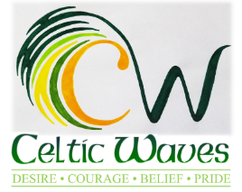

Filming and Photographing Permission:
Individual permission for taking video or photos:
Celtic Waves Swimming Club request permission to photography or get video footage your child/children when swimming, to work on their technique and show them how to improve it. This may happen a few times through the year. You will be advised by email of the date of each event

Photographs will be taken by an appropriate person appointed by Celtic Waves Swimming Club
Any images or video footage will be used in accordance with Swim Ireland Filming and photography policy. Photos will be used on social media, facebook and on our site. (only first name will be used).
Children must always be wearing a t-shirt over their togs or be fully dressed, swimmers in their swim suits is not allowed)

Consent
I consent I give my permission to be filmed and/or photographed for the event described. Any photographs and/ or part of the video may be used in accordance with Swim Ireland filming and videoing policy and Celtic Waves swimming Club filming / videoing policy.

Athlete Name___________________ Membership No________________________
Parents/Guardian’s Name:______________________ Date_____________________

If athlete is under 18 the parent/guardian must give consent
I confirm that I give permission to Celtic Waves swimming club to film or photograph my child/ren and confirm that I am the legal parent/guardian
Parent/guardian’s name_________________
Parent/guardian’s signature_________________________
Date -----------------------------------
Note
This permission will remain valid for one year.

