Dear Clubs,
We are on the count down to the start of Gerry Ryan Memorial Gala 2020. Just a few points to note in advance.

Session Start Times:

Friday w/up 6 pm, session start 6.30 pm
Saturday session start 9 am
Sunday session start 9 am
Warm Ups:
Find below the schedule of warm ups by club for both Saturday and Sunday morning. There will be one warm up for all Friday evening. Afternoon session warm ups will be open to all clubs. Please attend correct session in the mornings to avoid overcrowding. Note: coaches or team managers must supervise all warm-ups.
Other Notes:
- Technical Meeting will take place in the Pool Class Room at 8:15 am on Saturday morning. A coach or team manager MUST be present from each club.
- Team Manager and Coach ID wristbands for poolside access can be collected from the LSC registration desk in the main UL Arena reception on Friday evening and Saturday and Sunday mornings.
- Heat sheets can also be collected at the LSC registration desk in the main UL Arena reception for Saturday and Sunday. Friday evening’s heat sheets can be collect from the recorders desk poolside.
- Call rooms are located in the 3 squad changing rooms in UL. Please ensure your swimmers and team managers are familiar with this location.
- This will be a plastic free gala. Water carboys will be present around the pool, so please bring your own water bottles to refill.
- Reminder to clubs and swimmers to remain within the pool area. There will be an Ultimate Frisbee event going on in the halls, so no roaming around would be much appreciated.
Can you please ensure these details reach the relevant people in your club? We look forward to welcoming you all to Limerick for our Gala on 17th, 18th and 19th of Jan. Safe travelling.

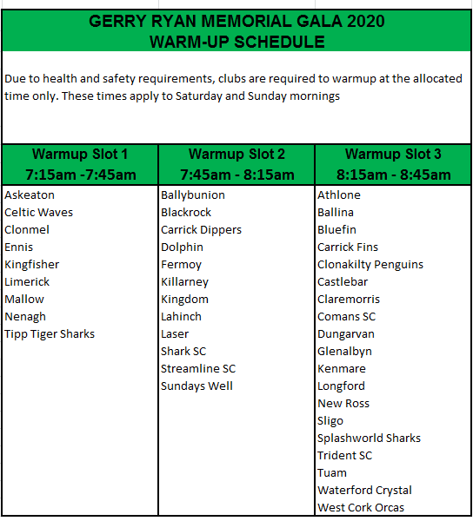

Yours in Sport,
Limerick SC Gala Committee
http://www.limswim.ie/

